April 1, 2019

Planning is underway for the annual Independence Day Parade, sponsored by Wisconsin Bank & Trust. The parade and celebration will be held on Thursday, July 4, 2019. We hope you’ll join us to celebrate Sheboygan’s Spirit on the Lake this 4th of July!

Visit Sheboygan, Inc., is coordinating this year’s festivities. As in years past, the parade begins at 9:00 a.m. The parade will start north on N. 8th Street at Center Ave., travel east on Michigan Avenue, and south on Broughton Drive.

For non-profit groups, there is no cost to participate in the July 4th parade. For commercial or for-profit businesses and organizations the entry fee is $100. All parade exhibits must utilize an Independence Day theme. All entrants must also submit samples of any literature that will be passed out during the parade.

Completed applications must be received by Friday, May 31, 2019. To be processed, applications must be accompanied by payment if applicable. Lineup will be determined by parade officials. Lineup confirmations will be sent by Friday, June 14, 2019.

Please make checks out to: Visit Sheboygan, Inc. and mail to 630 Riverfront Drive, Suite 200, Sheboygan, WI 53081. Sorry, only payment by check will be accepted and must be mailed in to the address listed above. Credit cards will NOT be accepted this year.

NOTE: WE ARE NO LONGER LOCATED IN THE CHAMBER OF COMMERCE BUILDING. PLEASE DO NOT GO THERE WITH PAYMENTS OR QUESTIONS. WE CAN BE REACHED EITHER THROUGH EMAIL OR PHONE CALLS ONLY. THANK YOU FOR YOUR PATIENCE AS WE AWAIT THE COMPLETION OF THE NEW VISITOR CENTER (OPENING SPRING OF 2020).

Direct questions, applications and entry fees to:

Shelly Harms
Tours & Events Manager
Visit Sheboygan, Inc.
630 Riverfront Drive Suite 200 (mailing address only)
Sheboygan, WI 53081
shelly@visitsheboygan.com or call (920) 395-1492

Thank you!
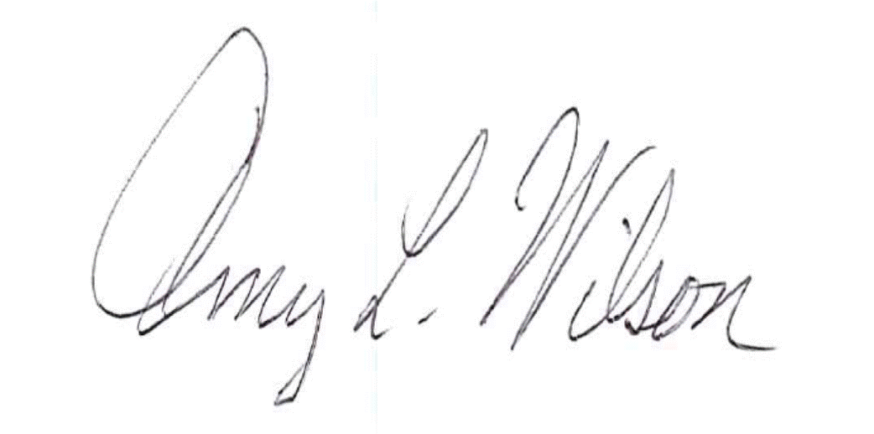

Amy L. Wilson, Ph.D.
President/CEO
Visit Sheboygan, Inc.

4th of July Parade Registration Form
Thursday, July 4, 2019

Due Date: Friday, May 31, 2019
Name of Group: | Please describe. Is there music with your entry? If so, is it “live” or recorded?
“Home” City:
Year Group Formed/Founded:
Number of Members in Parade: | How many vehicles or live animals will appear with your parade entry? Are there special requests (i.e. Would your group like to be next to another specific group?)
Age Range:
Contact Name:
Contact Phone Number:
Contact Email Address:
Mailing Address: (must be included)
WSCS Local Access Television (Charter Cable Channels 990. U-verse Channel 99.)
Please write a description about your float, group or exhibit in the parade. Channel 8 may use this description in its narrative of the parade to be aired on local access station WSCS. Please keep your description limited to 50 words.
Non-Profit or Commercial entry? (circle one)
Commercial entrants must pay a $100 entry fee. Please include payment along with a completed registration form.
Floats must be decorated with an Independence Day theme. If you plan to pass out any literature (non-profit or commercial), please include a sample copy with this completed application.
Return completed application by May 31, 2019 to:
Shelly Harms, Events & Tours Manager, Visit Sheboygan, Inc.
630 Riverfront Drive, Suite 200, Sheboygan, WI 53081 (mailing address only)
shelly@visitsheboygan.com or (920) 395-1492

Commercial entrants must pay a $100 entry fee (check only). There is no entry fee for non-profit groups. Applications received without payment will not be processed. Visit Sheboygan, Inc. is not responsible for undelivered, lost or damaged applications. Confirmation of application and entry acceptance will be sent by June 14, 2019. Lineup position will be determined by parade officials. More than half of participants request to be in the beginning of the parade; honoring all requests is simply not possible. Placement is determined based on parade mix such as music, vehicles, animals, live performance, similar float or exhibit, group size, mode of movement, etc.

4th of July Parade Rules
- Parade line-up begins at 7:30 am and participants are asked to be at their designated position by 8:45 am. Parade will commence at 9 am.

- No person participating in the parade shall throw, toss, pitch, or otherwise distribute items by any other means than personally handing such items to spectators along the parade route (including candy!). Do not cause spectators to leave the sidelines and enter the parade.
- Drinking of intoxicants by parade participants during the parade is prohibited.
- Roller or In-line skates, skateboards and non-motorized scooters must be approved. Please contact Visit Sheboygan, Inc.
- Parade participants shall not hinder the progress of the parade. Please maintain a steady distance in your line-up and keep the parade moving in a timely fashion. Parade Marshals will warn groups if they are causing extenuating, unacceptable lapses in the parade due to slow movement. Failure to increase pace may result Parade Marshals removing hindering group from the parade.
- Stand-still performances by parade participants shall be limited to those times when the parade is slowed or stopped.
- All live animal entries must include a clean-up crew or an acceptable alternative.
- No parade participants are allowed access to the parade route until the parade commences.
- All parade vehicles must be decorated with an Independence Day theme.

- A copy of literature being distributed during the parade shall be provided to the parade coordinator along with the completed parade application.

- Directions of Parade Marshals must be followed at all times.

Direct questions to shelly@visitsheboygan.com or call (920) 395-1492.

